SAILING INSTRUCTIONS

INTERNATIONAL SEA CUP EVENT OF THE CZECH REPUBLIC

16. Czech Marine Rally – ELAN CUP

In class Sea Yachts of type ELAN 340 and ELAN 350
Race No 12-7002
Date: 6-12^{-th} October 2012

Including the Czech Offshore Yachting Association
Sea International Cup 2012

- RULES
The Regatta will be governed by:
- The Rules as defined in The 2009-2012 ISAF Racing Rules of Sailing including its Appendices and all subsequent ISAF amendments,
- Radio Notices of the RC transmitted on VHF radio as provided in SI 16.
If there is a conflict between languages the English text will prevail
- ELIGIBILITY ENTRIES AND REGISTRATION
See the Notice of the Race
- AMENDMENTS TO SI, RC AND PC NOTICES TO COMPETITORS
  - All the RC and PC notices to competitors will be posted on the official notice board, which will be located, when boats are in a marina, close to them in a visible place ashore.
  - The Daily Notice of the RC as provided in SI 8 will be issued by the end of the regular skippers’ briefings before each race.
  - Amendments to SI will be given out at least 60 minutes before the committee boats leave for the starting area on the day they will take effect, except that if the start of the first race of the day or skippers briefing is earlier in the day the notice will be posted by 21:00 hours on the day before.
  - Changes of courses announced by radio on VHF as provided SI 8.3, 8.5 or 8.7 will be printed and posted after the finish of that day’s race.

- ADVERTISING
In accordance with regulation 20.3.1(b) ISAF Regulation 20 -”Advertising Code“ category C, advertising on the supplied boats is required by the organising authority. All boats are required to ensure that event organisers and sponsors supplied advertising is affixed and kept in position for the entire duration of the regatta. Boats may display advertising having first obtained the consent of the RC so long as such advertising is not on the first 20% of the hull, and does not interfere with advertising and bow numbers supplied by the organisers.

- TIME SCHEDULE OF RACES
  - A total of 10 races are planned in 6 race days.
  - The scheduled time for the warning signal for the first race of the first race day (Sunday 7th Oct) is 12:55 hours, on the following days 09:55 hours.
  - The scheduled time for the skippers briefing on the first race day (Sunday 7th Oct) is 11:30 hours, on following days at 08:00 hours.

- SIGNALS MADE ASHORE
  - Will be displayed on one of the RC vessels marked with a flag of the sponsor on her backstay berthing on moorings in the relevant marina.
  - When AP is displayed with two sounds = Race is postponed.
  - AP is moved half way down with one sound = the RC boats are leaving to start area, start of postponed race will be made not less then 30 minutes after this signal. On leaving the Marina AP will be re-hoisted with no sound.

- CLASS FLAG
Flag “T” will be used as the common class flag for the warning signal of the both classes.

- DEFINITION OF THE COURSES, PROCEDURE FOR COURSE CHANGES
  - Race courses for the next day will be determined in the Daily notice including:
- Positions of starts,
- Description of all course marks and their positions,
- Order and hand of passing of all marks,
- Positions of all auxiliary and final finishes,
- The scheduled time for the start,
- Time limits.
  - Positions in instruction SI 8.1 will be in co-ordinates used in Croatian charts, be given approximately and are to be used for orientation purpose only. Errors of position indications shall not be grounds for redress. This changes RRS 62.1(a).
  - Before the warning signal the RC can change the course by radio. This notice will list all deleted and all new course marks as provided in SI 8.1 (a) to (f).
  - Before the warning signal the RC can change the first leg by inserting new auxiliary windward mark(s). This will be announced by VHF radio as provided in SI 8.1 (b) to (c). The RC starting boat can signal this by displaying:
  - red flag = Inserted auxiliary windward mark(s) shall be left to port.
  - green flag = Inserted auxiliary windward mark(s) is left to starboard.
  - After the starting signal the RC can, as a safety precaution or in case of bad weather actual or forecast, change the course by VHF radio. This notice will list all deleted and new marks as provided in SI 8.1 (a) to (f). This notice will be given before the leading boat reaches the mark or gate that begins the changed leg. This changes RRS 33.
  - The RC may shorten the course at any auxiliary finish or near to any mark as provided rule RRS 32 and Race signals.
  - The RC may, by VHF radio, alter the definition of finishing marks or specify the finishing line in the event of shortening at a mark. This changes RRS 32.2.

- THE START
  - Both E-340 and E-350 classes start together.
  - Starting line will be between the mast of the RC vessel with a sponsor’s flag on her backstay at the starboard-end and a buoy at the port-end.
  - Races will be started by using RRS 26. Warning signal will be given 5 minutes before starting signal.
  - Timing will be given by radio on VHF dedicated channel. Times shall be taken from the visual signals, the absence of a sound or radio signal shall be disregarded, and it shall not be ground for redress. This changes RRS 62.1(a).
  - The RC may announce numbers of the boats under RRS 29.1 or 30.1 by radio. Failure to do so will not be grounds for redress.
  - Boats disqualified by a premature start under the ‘Black flag Rule’ will, in the event of a subsequent restart, have their numbers announced by radio rather than displayed visually on the committee vessel. This amends RRS 30.3.
  - A boat starting later than 10 minutes after her starting signal will be scored ”DNS” without a hearing. This changes RRS A4.1.

- MARKS OF THE COURSE
All marks will be listed and described in the Daily notice.

- FINISH
  - The finishing line will be between the RC vessel displaying a blue flag and a buoy unless the Daily notice designates an alternative. In conditions of low visibility the RC boat will, if practicable, be illumined by searchlight.
  - An auxiliary finish will be defined as a gate between two marks. A boat must pass between them as is directed.
  - If a boat has lost or has no visible number she shall report her number to the RC as she is finishing or passing an auxiliary finish.
  - Boats finishing or passing an auxiliary finish shall clear the line as soon as possible.

- TIME LIMITS
  - Time limits will be defined or changed for each auxiliary and final finish as provided in instruction SI 8. If no boat finishes or passes an auxiliary or final finish within the corresponding time limit the result of the race will be taken from the order at the previous auxiliary finish. If no boat has passed the first auxiliary finish within the time limit the race will be abandoned.
  - The RC may, for safety reasons or if in their opinion the fleet will fail to meet the next time limit, finish the race and take the finishing order from the last auxiliary finish.
  - The time limit for finishing will be defined or changed for all auxiliary and final finishes as provided in instruction SI 8. Boats failing to finish within this limit after the first boat sails the course and finishes will be scored ”DNF“.

- PENALTY SYSTEM
  - RRS 44.1 and 44.2 are changed so that the two turn penalty is replaced by a one turn which includes one tack and one jibe required.
  - If a boat retires after finishing she will be scored with a scoring penalty 20% as provided RRS 44.3(c).
  - A boat that has taken a penalty or retired under RRS 44.1 shall complete an acknowledgement form at the RC vessel at least 15 minutes before the end of protest time.

- PROTESTS
  - A boat intending to protest shall always notify the protestee or RC occasionally at the first reasonable opportunity by radio. This adds to RRS 61.1(a).
  - All protests must be delivered in writing on a protest form within the protest time limit to the RC vessel. Protest forms are available from the committee vessel.
  - Protest time is 60 minutes after the RC finishing vessel has moored in the marina. The protest time limit will be posted. PC notice will be posted within next 15 minutes after this time to inform competitors of the times of hearings in which they are parties or named as witnesses.
  - On the last scheduled day of racing a request for reopening a hearing shall be delivered within the protest time limit when the decision was posted on previous day, or no later than 30 minutes after the decision was posted in that day. In that day a request for redress based on PC decision shall be delivered no later than 30 minutes after the decision was posted. These change rules RRS 62.2 and 66.
  - Only the race committee or PC may protest for breaches of instruction SI 4, 13.3 and 19. This changes rule RRS 60.1(a). Penalties for these breaches may be less than disqualification if the PC so decides.
  - If the PC finds that a boat gained an advantage by taking a penalty, or if a boat has caused damage or injury it can: -
(a) Decide to increase a scoring penalty,
(b) Disqualify a boat from a race,
(c) Disqualify a boat from more than one race, or from the event.

- SCORING SYSTEM
10 races are planned. When 8 and more races are completed, there will be two discards, in case from 4 to 7 races are completed, there will be one discard. Otherwise, all races will count.

- RADIO COMMUNICATION
  - All radio notices of the RC will be given on a pre-determined VHF channel announced in writing before the start of the event.
  - Failure of boats to receive a radio message from the Race Committee will not be grounds for redress.
  - Boats shall only make radio transmissions to communicate with the RC, to announce a protest or in case of emergency.
  - A boat is responsible for continuous monitoring of this channel and for preparing and giving accurate information as required by the RC.
  - During the starting sequence a racing boat can use radio in emergency only.
  - Competitors’ boats shall identify themselves on the radio solely by their starting numbers, and shall call RC boats by their call signs, all of which will be made available in writing before the start of the regatta.

- LIFELINES AND CREW POSITION
Lifelines shall be kept taut and crew position shall to be in accordance with RRS 49.2.

- SAFETY REGULATIONS
  - Competitors under 18 years of age shall wear adequate personal buoyancy at all times whilst under way. Penalty for breach of this requirement is ”DSQ“ from the race nearest in time to the incident without hearing.
  - A boat that retires from a race shall notify the RC as soon as possible.
  - It is on skipper’s responsibility and decision exclusively if the boat starts or continues at a race at given condition.

- EQUIPMENT
  - The organising authority may take steps to ensure equality of all boats. Any action by the race committee intended to equalise boat speed and/or manoeuvrability shall not be grounds for redress.
  - Permitted additions to, or removal of equipment is defined in appendix II.
  - A boat and her equipment, except as specified in SI App I, shall not be modified, replaced or removed without prior written permission of the RC or race technical manager. All equipment shall be used, housed and adjusted in accordance with its designed purpose.
  - Boats shall be equipped with an all braced mainsail a headsail rolled onto the forestay, E-340 by symmetrical spinnaker and E-350 by asymmetrical gennaker. The areas of these sails shall correspond to the class specification and shall be made from woven material with polyester fibre reinforcement entirely and without containing any lamination or sheet material. Carbon fibres in sails are forbidden. When a boat is supplied equipped with another sail or with a sail of another material the crew shall inform the race technical manager immediately and ask a replacement sail.
  - The crew is fully responsible for insuring that all equipment, its adjustment and position is in accordance with its designed purpose and corresponds to the local safety regulations. Where there is a difference from the design specification or an applicable safety rule which could influence the sailing capability or safety of the boat the crew shall inform the race technical manager immediately and conform to his requirements.
  - The lessee is responsible for any damage due to unskilled equipment handling. Irreversible boat or equipment adjustments are not permitted. Boats and their equipment shall be returned at the end of the regatta in their original condition with all their original equipment.
  - However slight, malfunctions, impairments, repairs, or replacements concerning the boat and her equipment shall be immediately reported in writing to the race technical manager no matter whether the occurrence was during a race or not.
  - Boats can be cleaned underwater but without the use of any chemicals or breathing apparatus. The RC or the race technical manager may exceptionally consent for the use of breathing apparatus only.
  - Boats shall not be hauled out during the regatta except with prior written permission of the race technical manager.
  - Diesel tanks shall not be drained in whole or in part.
  - The RC, PC or the race technical manager can order an inspection of a boat and her equipment. Crew shall facilitate inspections and comply with the inspector’s requirements.
  - When a boat has a fault in equipment supplied by the organising authority she shall display a red flag and continue to race if possible. If the PC decides that a boat’s finishing place, through no fault of her own, is significantly worse or she cannot start in a race and an efficient crew wouldn’t be unable to prevent the fault at same conditon, she can apply for redress as provided by RRS 64.2. This changes RRS 62.1.
  - The penalty for a breach of this SI can be ”DSQ“ of the boat after a hearing from a race or from the whole regatta.

- USING MOTOR WHILE RACING
If a racing boat is forced to run the engine for any reason she shall report to the RC at first reasonable opportunity giving the running time and reasons for use, with any other details that may be relevant. The PC may require a hearing to consider any use of engines whilst racing.

- CREW ALTERATION
No crew alteration will be allowed without the prior written approval of the RC.

Appendix I. Windward –Leeward courses

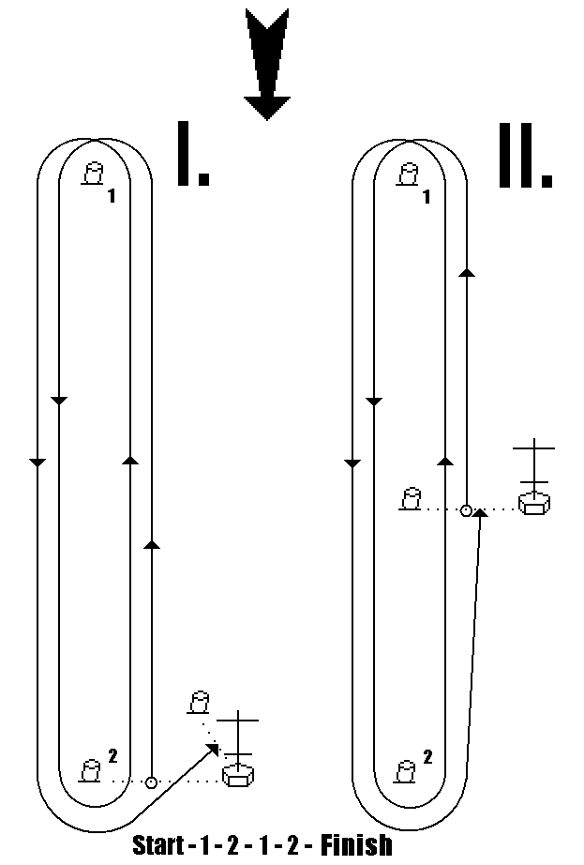

Note: Mark No 2 can be replaced by a gate made from two buoys
Appendix II. ALLOWED CHANGES OF EQUIPMENT

1.1) Only the following may be put ashore:
- unnecessary crockery and cutlery,
- unnecessary bedding, except mattresses,
- sunshade covers including its frame,
- unnecessary items taken on board in compliance with 1.2) of this appendix.

1.2) Only the following may be loaded aboard:
- clothing,
- bedding,
- food and drink,
- galley equipment,
- tools including spare parts for small repairs,
- personal, navigation, and safety equipment providing that the boat’s original equipment stays aboard,
- personal equipment that does not affect the sailing capability of the boat.

1.3) Items that can be loaded into a boat and used while racing for adjustment either of rigging, or components designated to control the boat:
- shackles and snap hooks,
- rope up to 6 mm diameter of any length designated for repairs or to prevent failings,
- easy removable adhesive tape,
- wind indicators (tell tales) located on sails or standing rigging,
- markers or adhesive marks for trim indication or tackle labelling,
- nautical equipment including electronic devices and charts,
- a maximum of two single sheave blocks designated for adjustment of leading spinnaker and jib sheets. The ratchet blocks is forbidden,
- rope up to 30 mm diameter maximum 2 x 5m long designated for adjustment of leads for spinnaker and jib sheets,
- cover for spinnaker or for other sails,
- Tiller extension including ferrule for fixing to tiller.

1.4) While racing the anchor should be removed from the bow holder to the bow anchor storage area ready to use at the end of the anchor chain.

NO OTHER EQUIPMENT CHANGES OR ALTERATIONS ARE PERMITTED!

Prague 16-th September 2012
Petr Sladecek, PRO

